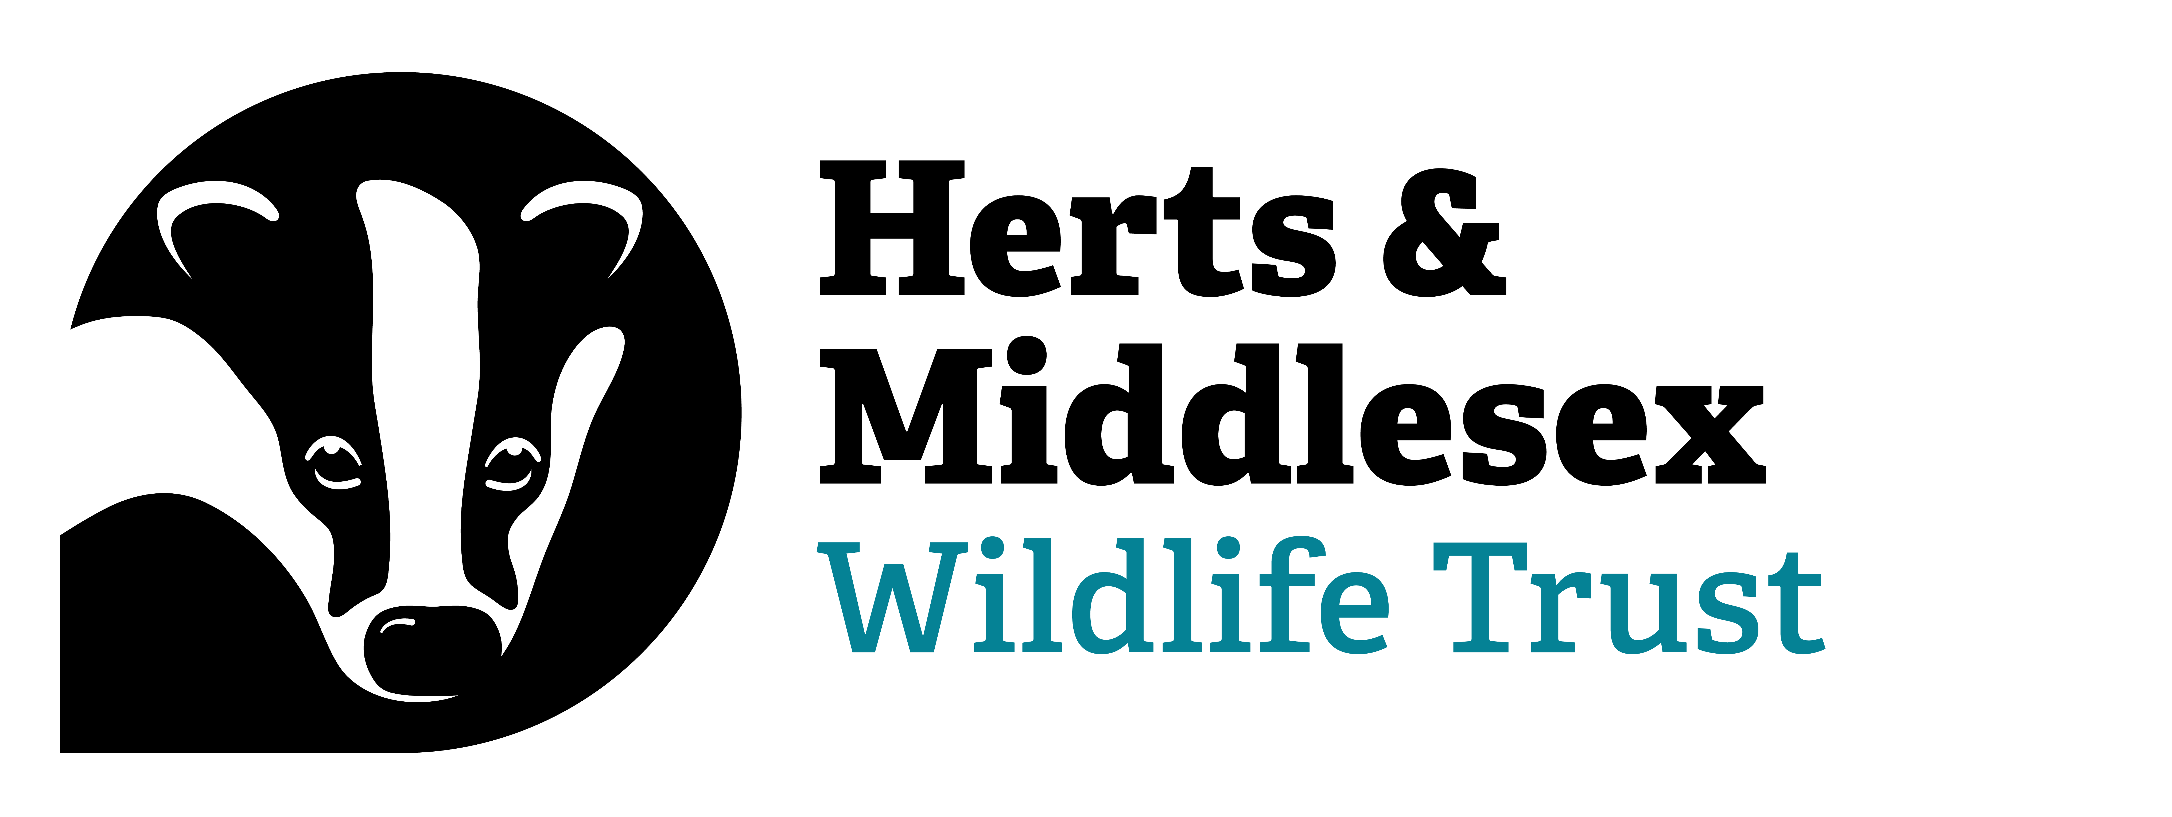

Herts and Middlesex Wildlife Trust Photography Competition 2022
Terms & Conditions
These terms and conditions govern the Herts and Middlesex Wildlife Trust Wild Snaps Photography Competition 2022. The competition organiser is Herts and Middlesex Wildlife Trust. By accepting the Terms & Conditions of the competition and subsequently submitting your photographs, you have entered into an agreement with the organiser.
The organiser reserves the right to modify these terms and conditions without notice.
1 Competition entry
By entering the competition, you agree to the provisions of these terms and conditions and to comply fully with them. The competition opens on Friday 19 August 2021 and closes on Wednesday 7 September 2021 at 23:59. Submissions must be received by the closing date. Any submissions received after the closing date will not be accepted.
2 Eligibility
The competition is open to anyone of any age with the following exceptions:
- Employees or relatives of employees of Herts and Middlesex Wildlife Trust
- Professional photographers, defined for the purposes of this competition as those who earn more than half their income through photography
Those in doubt as to their eligibility must contact the organiser for clarification before entering. The organiser’s decision on eligibility is final. If you are under the age of 18, you must have permission to enter from your parent or guardian. By submitting an entry for the competition, your parent or guardian is deemed to have given such consent and to agree to the use of the entry as described in these terms and conditions.
3 What to enter
Photographs must be digitally submitted at a resolution of 300 pixels per inch at A4 (i.e. image dimensions of at least 1920 x 1080 pixels) in JPG/JPEG file format, maximum file size 10MB. The organiser reserves the right to crop and enhance where appropriate photographs. If in doubt, please ask us before submitting by contacting events@hmwt.org.uk.
Photographs must not have won an award in any other photographic competition. All images must be taken within the counties of Hertfordshire or Middlesex or depicting wildlife that can be found in aforementioned counties. Images taken by a drone or similar technology will be refused.
The photographs will be judged against the following brief:
- Represent the wildlife and/or wild places in the counties of Hertfordshire or Middlesex
- Images must represent the natural environment and therefore, images of animals raised or held in captivity or pets are not eligible (including livestock).
- Images must not contain identifiable people
- Submissions that appear to Herts and Middlesex Wildlife Trust to have been created in a way that breaches wildlife law are not eligible and may lead to us passing the details onto the police or relevant authority.
- The organiser reserves the right to refuse any entry to the competition for any reason.
- Digital adjustments and cropping are acceptable. However, the organiser reserves the right to withdraw submissions that are heavily edited.
4 How to Enter
The competition opens on Friday 19 August 2022 and the closing date for submissions is Wednesday 7 September 2022 at 23:59. Submissions received after this time will not be accepted.
Applicants may enter a maximum of two images. Entries must be submitted digitally via the competition website. No other forms of submission will be accepted.
By submitting images to the Herts and Middlesex Wildlife Trust Photography Competition, each entrant confirms and warrants that:
- They are the sole author of each entry and that it is their original work;
- They own the copyright and any other intellectual property rights of each image;
- They have the permission of anyone pictured in the image (or, where the image shows any persons under 18, the consent of their parent/guardian) for the usage rights required by Herts and Middlesex Wildlife Trust and will indemnify Herts and Middlesex Wildlife Trust against any claims made by any third parties in respect of such infringement;
- They have not licensed or disposed of any rights in the image that would conflict with uses to be made by Herts and Middlesex Wildlife Trust;
- They have received any necessary permissions from the owner(s) of objects including buildings included in submitted images for the usage rights required by Herts and Middlesex Wildlife Trust and will indemnify Herts and Middlesex Wildlife Trust against any claims made by any third parties in respect of such infringement.
5 Judging
All photos submitted will be shortlisted by Herts and Middlesex Wildlife Trust’ judging panel and the final 30 images will put forward for online public vote starting on Monday 19 September. The public vote ends on Wednesday 28 September. The winning photo will be the one with a majority of votes. If there is a tie between photos, the organiser reserves the right to make the final decision, judging the images against the brief.
6 Announcement of winners
The winners will be contacted by telephone or email as soon as possible after the voting has closed, at the latest by the end of September 2022 and publicly announced via social media and other Trust publications.
7 Usage Rights
By entering the competition, you grant Herts and Middlesex Wildlife Trust a non-exclusive, irrevocable licence to reproduce, enlarge, publish or exhibit, on any media, the images for any purpose to further its charitable aims and objectives. This will include but may not be limited to:
- On the Herts and Middlesex Wildlife Trust website and social media channels
- In the Trust’s Wildlife Matters members’ magazine
- In conjunction with sponsors to promote this photography competition
- In external print and digital press to publicise the competition and/or the work of Herts and Middlesex Wildlife Trust
- In any other Herts and Middlesex Wildlife Trust promotional materials, including but not limited to information leaflets, booklets or posters
- Merchandise, including but not limited to greeting cards, calendars, prints and posters, for sale by the Trust online or otherwise.
Any funds raised from related sales will be used by Herts and Middlesex Wildlife Trust to further its charitable aims. Copyright will remain with the photographer. The organisers will make every reasonable effort to ensure that name credits are given to any photograph published in any medium for any purpose.
8 Data Protection
Herts and Middlesex Wildlife Trust will keep your details on its secure database to enable the Trust to administrate the competition, use your images (see usage rights) and contact you with news directly relating to this competition (e.g. the outcome).
With your permission, Herts and Middlesex Wildlife Trust will also send you information about other activities, plus regular updates about the wildlife in Hertfordshire and Middlesex, ways to get closer to nature, project updates, events, volunteering opportunities and fundraising news and other information about Herts and Middlesex Wildlife Trust or the Wildlife Trusts.
We value your privacy and promise to keep your personal details safe and secure, and we will never sell your data. You can read our full privacy policy at hertswildlifetrust.org.uk/privacy.
9 Indemnity and Limitation of Liability
To the maximum extent permitted by law, Herts and Middlesex Wildlife Trust excludes its liability for any loss, damage, injury, cost or expense suffered by you, whether directly or indirectly and howsoever caused, in connection with the competition and use of any prize.
Nothing in these terms and conditions shall exclude Herts and Middlesex Wildlife Trust’s liability for death or personal injury arising from Herts and Middlesex Wildlife Trust’s own negligence or any other liability that cannot, as a matter of law, be excluded. You agree to indemnify Herts and Middlesex Wildlife Trust and keep Herts and Middlesex Wildlife Trust indemnified against any loss, damage, injury, cost or expense suffered by Herts and Middlesex Wildlife Trust as a result of your entry in the competition, including (but not limited to) any claim of infringement of intellectual property rights made by any third party.
10 General
The information given in these Terms & Conditions is correct, but Herts and Middlesex Wildlife Trust reserves the right to change any of it without prior notice. By entering the competition, entrants will be deemed to have agreed to be bound by these Terms & Conditions. Any breach of these Terms by an entrant will void their entry. If a breach has occurred, but is discovered after the award of any prize, then the organisers may require the return of that prize. Herts and Middlesex Wildlife Trust’s Privacy Policy applies to the competition and use of the Herts and Middlesex Wildlife Trust Photography competition website. You can find the privacy policy at www.hertswildlifetrust.org.uk/privacy.

You agree that if you are a winner you will take part in and cooperate fully with reasonable publicity and to the use of your name and photograph in such publicity. These Terms and Conditions shall be governed and construed in accordance with English Law and will be subject to the exclusive jurisdiction of the English court.

