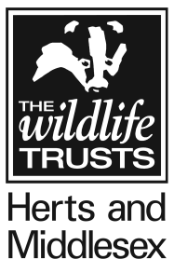
EQUAL OPPORTUNITIES MONITORING FORM

Herts & Middlesex Wildlife Trust operates an Equality and Diversity policy and no person will be discriminated against in seeking employment or during such employ, with the Trust on the grounds of age, disability, ethnic origin, gender, marital status, political allegiance, race, religious belief, sexual orientation, responsibility for dependants or unrelated criminal convictions.

The following information will be used only for monitoring our Equality and Diversity Policy and will not be used for any other purpose. It will be separated from the application form before short-listing and kept confidentially by the personnel department.

Post applied for:-

Gender M □ F □

Date of birth: …………….. Age: …………

Do you consider yourself disabled? Yes □ No □

Registration Nos. : …………………………………

Please describe your ethnic origin by ticking one of the following boxes:-

European White □
European Black □

White other □ …………………………….

Afro-Caribbean □
African □
Asian □

Other □ …………………………….

Where did you see this post advertised?

…………………………………………………………………………………………………

Please send the Equal Opportunities Form with your Application Form to recruitment@hmwt.org by the closing date.

