Title | First Name
Surname
Address
Email
Telephone number
Name of Event
Date of Event

Protecting Wildlife for the Future

A donation is worth more with Gift Aid*
To enable us to claim back the tax already paid on your donations (at least 25p for every £1 you donate), please tick and date the boxes below.
Full Name | Full address | Postcode | Amount | Date paid | Gift Aid it
ONLINE SPONSORSHIP: Can’t get your sponsorship form to all your friends? Collect donations online on www.justgiving.com/hertsandmiddlesexwildlifetrust |  |  | SUB TOTAL  (continued overleaf) |  | £

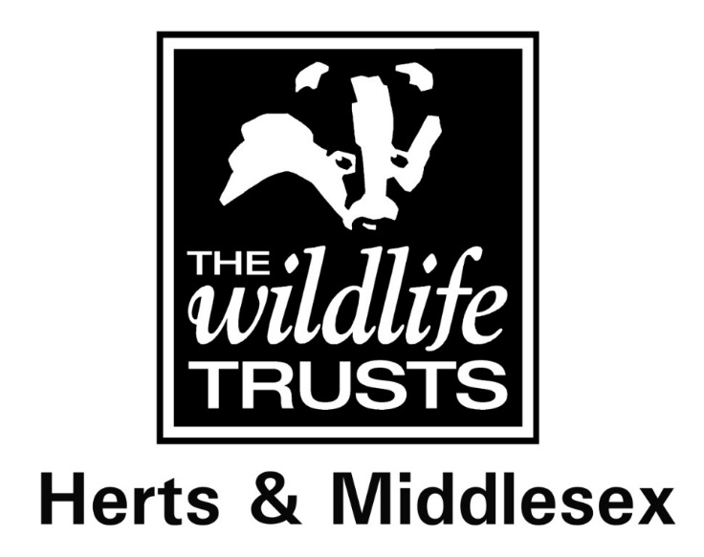
Thank you for sponsoring me! All proceeds from my event will go towards supporting the important conservation work of Herts & Middlesex Wildlife Trust.
* Gift Aid By ticking the Gift Aid box above you agree to the following statement: I am a UK taxpayer and understand that if I pay less Income Tax and/or Capital Gains Tax in the current tax year than the amount of Gift Aid claimed on all my donations it is my responsibility to pay the difference. I agree to notify Herts & Middlesex Wildlife Trust, if I change my name and/or address, or if in the future my circumstances change and I no longer pay sufficient tax on my income and/or capital gains tax. I will also tell the Trust if I cease to be a UK income tax payer. I understand I can cancel this Gift Aid declaration at any time.

Data Protection Herts & Middlesex Wildlife Trust will use the details you provide on this form to claim Gift Aid on your donations and for no other purpose. We will never share your personal details with any other third party or organisation. For more information on how we look after your personal details, read our privacy policy on hertswildlifetrust.org.uk/policies.

A donation is worth more with Gift Aid*
To enable us to claim back the tax already paid on your donations (at least 25p for every £1 you donate), please tick and date the boxes below.
Full Name | Full address | Postcode | Amount | Date paid | Gift Aid it
ONLINE SPONSORSHIP: Can’t get your sponsorship form to all your friends? Collect donations online on www.justgiving.com/hertsandmiddlesexwildlifetrust |  |  | SUB TOTAL  (this side) |  | £
THANK YOU FOR YOUR SUPPORT |  |  | SUB TOTAL  (other side) |  | £
 |  |  | TOTAL |  | £
Please return your completed form and sponsorship received to

Herts & Middlesex Wildlife Trust
Grebe House
St Michael’s Street
St Albans
AL3 4SN

Please make cheques payable to ‘Herts and Middlesex Wildlife Trust’ (please do not send cash in the post).

